Data Preprocessing Report for CNN
AI-Assisted Analysis of Student Answer Scripts
Using a CNN-LSTM Hybrid Deep Learning Model
Leclercq Simon
CESI École d’ingénieurs FISE A4 Informatique 2026 - 2027
Research Internship, Faculty of Artificial Intelligence (FAI), Universiti Teknologi Malaysia (UTM), Kuala Lumpur
September 2026 – January 2027

SUMMARY :

1) PROJECT CONTEXT 2
2) RAW DATA DESCRIPTION 2
2.1) DATA FORMAT 2
2.2) INPUT DATA ORGANISATION 2
3) PREPROCESSING PIPELINE 3
3.1) GREYSCALE CONVERSION 3
3.2) RESIZING 4
3.3) REPLICATION INTO 3 CHANNELS (RGB) 4
3.4) IMAGENET NORMALISATION 5
3.5) DATASET CONSTRUCTION AND LABELLING 5
3.6) DATA AUGMENTATION 5
4) VALIDATION STRATEGY 6
4.1) Stratified K-Fold 6
5) SAVING AND REPRODUCIBILITY 6
6) PIPELINE SUMMARY 7

1) PROJECT CONTEXT
This document describes the data preprocessing step of a research project on the use of CNN models on exam papers from primary school students in Malaysia. It follows the data cleaning report and comes before model training.
The dataset consists of scanned papers from the exam "Instrumen Fasa 2, Program Intervensi Tahun 1, Kemahiran Asas Numerasi" (basic numeracy skills, 7-year-old students, Year 1). Each paper has 15 pages and 30 questions covering 12 different skills.
The project aims to classify each student answer as correct or incorrect, then to derive a mark for each student (correct answer = 1 point, incorrect answer = 0) and compare it with the mark given by the teacher. Two approaches are studied one after the other.
- CNN: the answer is classified directly from its image. This is the approach covered by this document.
- LSTM: the answer is classified from the image converted into a sequence of features. This approach needs extra preprocessing, which will be described in a separate document.
Before preprocessing, the raw scans go through a cleaning step, described in a separate report. It removes the teacher's red annotations and crops each page into individual exercises, then each exercise is manually labelled as correct or incorrect. The preprocessing presented here therefore starts from these cleaned and labelled exercise images, and turns them into tensors ready for training.

2) RAW DATA DESCRIPTION

2.1) DATA FORMAT
The input data of the preprocessing is not the scans of full papers, but the exercise images produced by the cleaning step. Each image is one student's answer to one exercise. It was cropped from the scanned page, the teacher's red annotations were removed from it, and it was then manually labelled as correct or incorrect.
Resolution: 1519 × 1052 pixels for most exercises (landscape format, 2 exercises per page), with a height ranging from 1028 to 1076 pixels depending on the page. Exercise q03, which takes up a full page, is 1519 × 2104 pixels (portrait format).
Format: JPEG, 3 colour channels (BGR)
Content: printed questions, handwritten student answers (numbers, circling, colouring).

2.2) INPUT DATA ORGANISATION
The data is organised in the following folder structure.
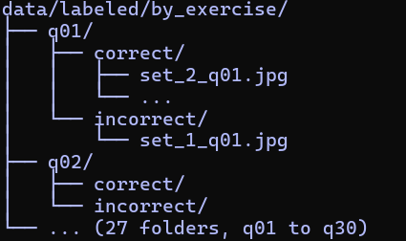
Each qXX folder groups the students' answers to the same exercise, split between the correct/ and incorrect/ subfolders according to the manual labelling. The name of each file (set_X_qYY.jpg) shows the student and the exercise the image comes from.

3) PREPROCESSING PIPELINE
The preprocessing follows a sequential pipeline of 5 steps, designed to turn the exercise scans into tensors that a CNN model can use. Each step is justified by the technical constraints of the project (small dataset, transfer learning).

3.1) GREYSCALE CONVERSION
Operation: conversion of the image from 3 BGR channels to 1 greyscale channel using cv2.cvtColor(img, cv2.COLOR_BGR2GRAY).
Justification: after cleaning, the teacher's red annotations have been removed and the images are almost entirely black and white. The questions are printed in black and the answers are written in grey pencil. The only remaining colour comes from some colouring exercises. For these exercises, the useful information is the coloured area and not the colour used. A coloured area stays clearly visible in greyscale, as shown in the figure below. The conversion therefore reduces the data size by a factor of 3 without losing information useful for marking, speeds up training and lowers the risk of overfitting.
Transformation: shape (1076, 1519, 3) -> (1076, 1519)
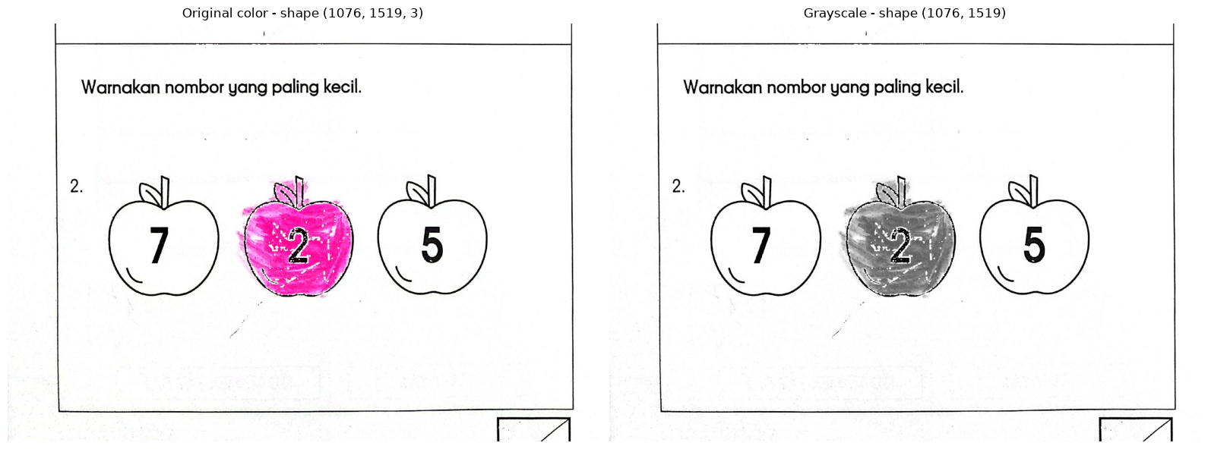

3.2) RESIZING
Operation: resizing of each image to 224 × 224 pixels using cv2.resize(gray, (224, 224)).
Justification: 224 × 224 is the standard input size of models pre-trained on ImageNet. ConvNeXt-Tiny was pre-trained at this size. EfficientNetV2-S and EfficientNetV2-M were pre-trained on larger images, but they accept any input size. Using 224 × 224 for all three models makes it possible to compare them on the same images.
Note: the original aspect ratio (landscape, about 1.4:1 for most exercises, portrait for q03) is changed to get a square format. This distortion is accepted because it is the same for all images of a given exercise, and pre-trained CNNs adapt to it during fine-tuning. An alternative would be to keep the ratio with padding, but this would add empty areas with no information and would reduce the useful resolution.
Transformation: shape (1076, 1519) -> (224, 224)
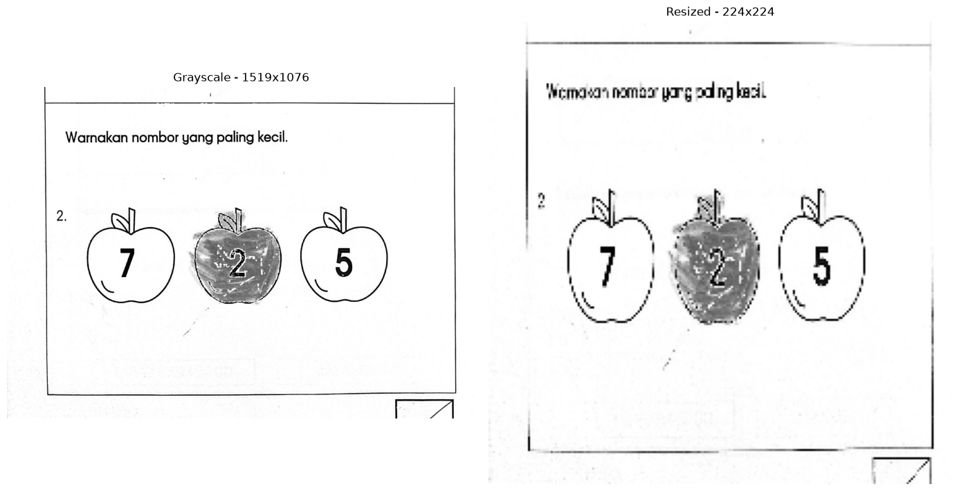

3.3) REPLICATION INTO 3 CHANNELS (RGB)
Operation: replication of the greyscale channel into 3 identical channels using np.stack([resized, resized, resized], axis=-1).
Justification: CNN models pre-trained on ImageNet expect a 3-channel (RGB) input. Even though our images are in greyscale, we need to simulate an RGB image to be able to use the pre-trained weights. Each channel holds the same information, but this lets the network use the filters learned on ImageNet, which work on 3 channels.
Transformation: shape (224, 224) -> (224, 224, 3)

3.4) IMAGENET NORMALISATION
Operation: normalisation of pixel values using ImageNet statistics. The values are divided by 255 to bring them between 0 and 1, then centred and scaled using the ImageNet mean and standard deviation.
mean = [0.485, 0.456, 0.406]
std = [0.229, 0.224, 0.225]
normalized = (rgb / 255.0 - mean) / std

Justification: pre-trained CNNs were optimised for data normalised with these specific statistics. Using a different normalisation (for example a simple division by 255) would create a gap between the input data distribution and the one the network expects, which would lower the performance of transfer learning. After normalisation, pixel values are centred around 0, with a typical range of [-2.12, 2.64].
Transformation: integer values [0, 255] -> float values [-2.12, 2.64]

3.5) DATASET CONSTRUCTION AND LABELLING
Operation: loading of all labelled exercise images, application of the four previous steps to each of them, then assembly into a single tensor with assignment of binary labels.
Labels: correct answer -> label 1, incorrect answer -> label 0. The label comes from the subfolder in which the image was placed during manual labelling (correct/ or incorrect/).
Final shape of tensor X: (N, 224, 224, 3)
Final shape of tensor y: (N,)
N is the total number of labelled exercise images.

3.6) DATA AUGMENTATION
Objective: artificially increase the diversity of the dataset to reduce the risk of overfitting, which is especially important with a small number of samples.
Three random transformations are applied to each image.
Random rotation (±5°): simulates alignment variations during scanning. The amplitude is deliberately small because these are scanned documents, not natural photographs.
Brightness variation (±10%): simulates quality differences between scanners or between scanning sessions.
Gaussian noise (σ = 0.01): simulates scanning artefacts and adds a slight variability to textures.
Application: augmentation is not done once and for all during preprocessing, and no augmented image is saved. It is applied on the fly during training. At each epoch, each training image gets new random transformations, so the model sees a slightly different version of the image each time. Validation images are never augmented, so that the evaluation is based on the real images. The preprocessing notebook only shows a visual example of it.

4) VALIDATION STRATEGY

4.1) Stratified K-Fold
Model validation uses a stratified K-Fold Cross Validation strategy with K = 5. The dataset is split into 5 subsets (folds) of equal size. The model is trained 5 times, each time using 4 folds for training and 1 fold for validation, with a different validation fold at each iteration.
Stratification: each fold keeps the same correct / incorrect ratio as the full dataset. This ensures that the model is always evaluated on a representative distribution and that the minority class (incorrect) is present in every fold.
Reproducibility: the split is made with a fixed random seed (random_state = 42). The same folds are used for all compared models, which makes it possible to compare their scores fold by fold. The preprocessing notebook shows this split for information only. It is applied during training.
Justification: with a small dataset, a simple train/test split could give biased results depending on how the exercises are randomly distributed. K-Fold gives 5 evaluations whose mean and standard deviation provide a more reliable estimate of the real performance of the model.
Limitation: the split is made at the exercise level and not at the student level. Exercises from the same student can therefore be in both training and validation, which lets the model get used to that student's handwriting. A split by student is planned once the dataset contains more papers.

5) SAVING AND REPRODUCIBILITY
The preprocessed dataset is saved in NumPy format (.npy) so that it can be loaded quickly during experiments, without redoing the preprocessing at each session.
X_exercise.npy: tensor containing all preprocessed images, shape (N, 224, 224, 3)
y_exercise.npy: tensor containing the binary labels (1 = correct, 0 = incorrect), shape (N,)
names_exercise.npy: file name of each image (for example q01/correct/set_2_q01.jpg), in the same order as X and y
All the preprocessing code is versioned on GitHub and organised as a Jupyter notebook, with Markdown cells documenting each step and intermediate visualisations to check that the pipeline runs correctly. The data itself is not versioned because of its size, but it can be regenerated from the raw scans by running the notebooks in order.

6) PIPELINE SUMMARY
The full preprocessing pipeline can be summarised as follows.
- Cleaned and labelled exercise images
- Greyscale conversion
- Resizing to 224×224
- Replication into 3 RGB channels
- ImageNet normalisation
- Dataset construction and binary labelling (correct = 1, incorrect = 0)
- Saving in .npy format
Steps applied later during training are data augmentation (on the fly, training images only) and stratified K-Fold (5 folds).

